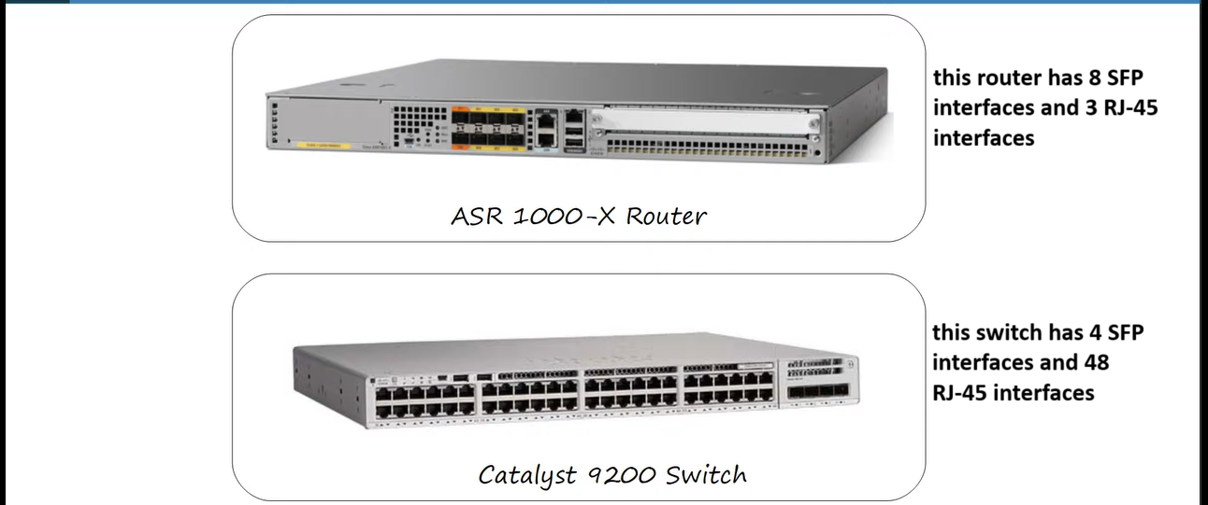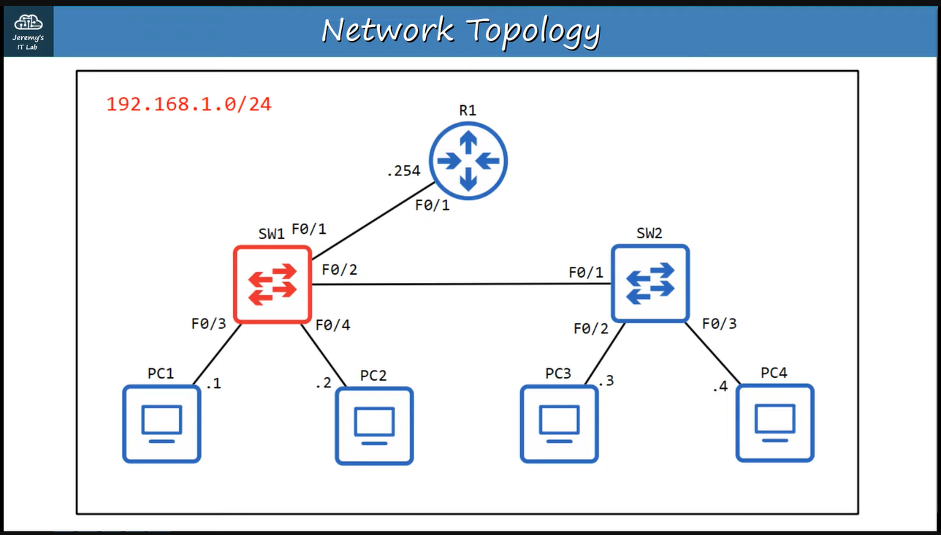

**This is a topology and we’ll use switch “SW1” to understand the configuration of switch interfaces.**

**Remember that ↓**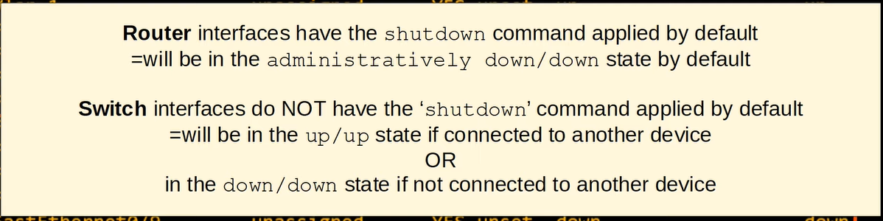

**E.g. ↓**

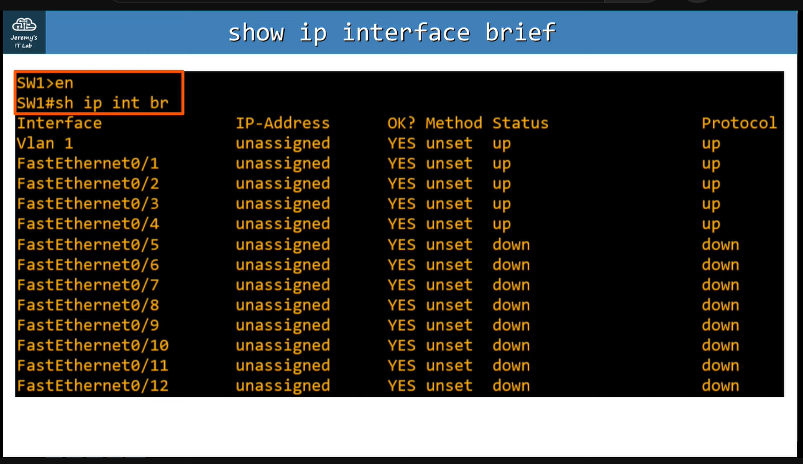**In this, status of those ports is “up” which are connected and “down” which are not connected.**

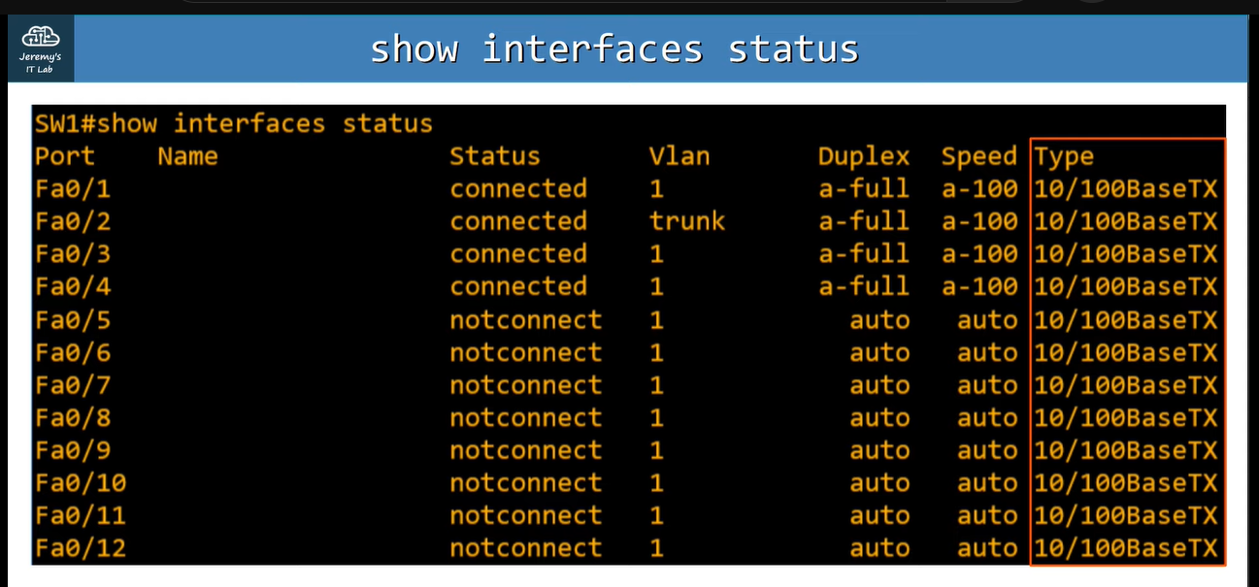**Type column indicates to the type of interface, i.e., it is RJ-45, SFP or etc.**

**We can set speed and duplexity of an interface manually, e.g. ↓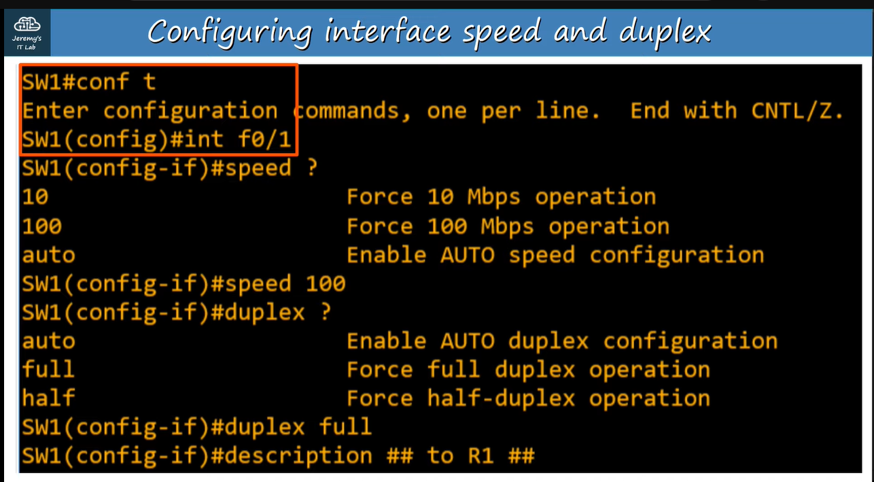Using “description” command we can add it in “name” column, as you can see ↓We can shutdown the interfaces manually, we can shutdown multiple interfaces at once ↓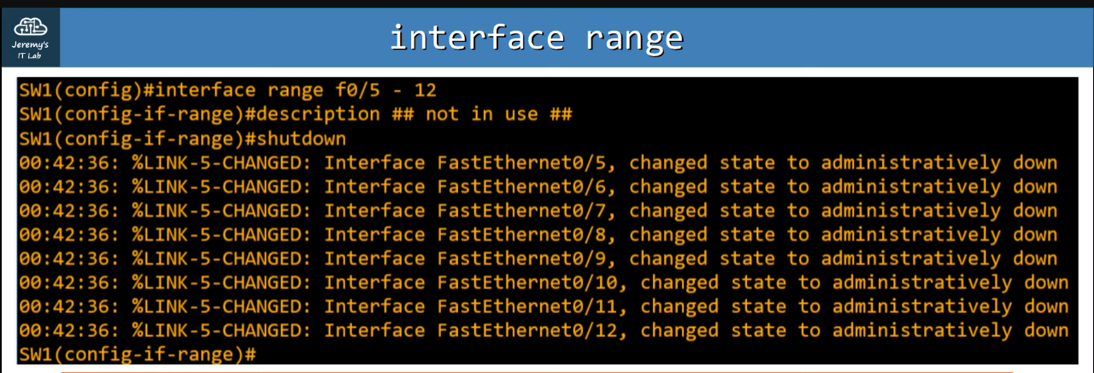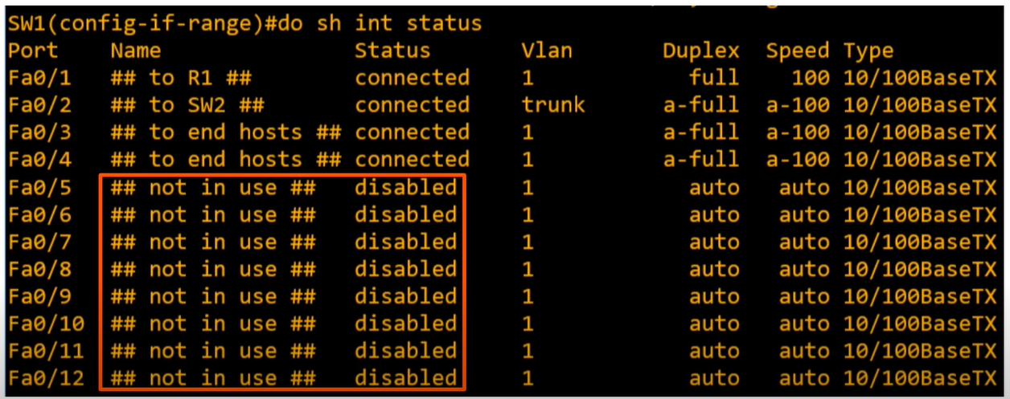Now their statuses are “disabled” rather than “not connect”.**

**Using the range command like this, we can disabled or enable those interfaces which we want ↓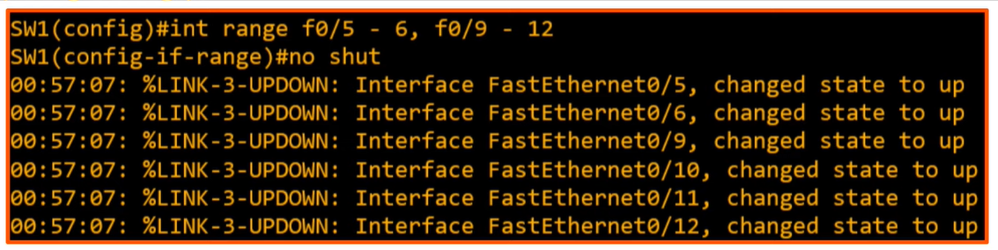in this, interfaces from 5 to 6 and from 9 to 12 are enabled but interfaces 7 and 8 are still disabled.**

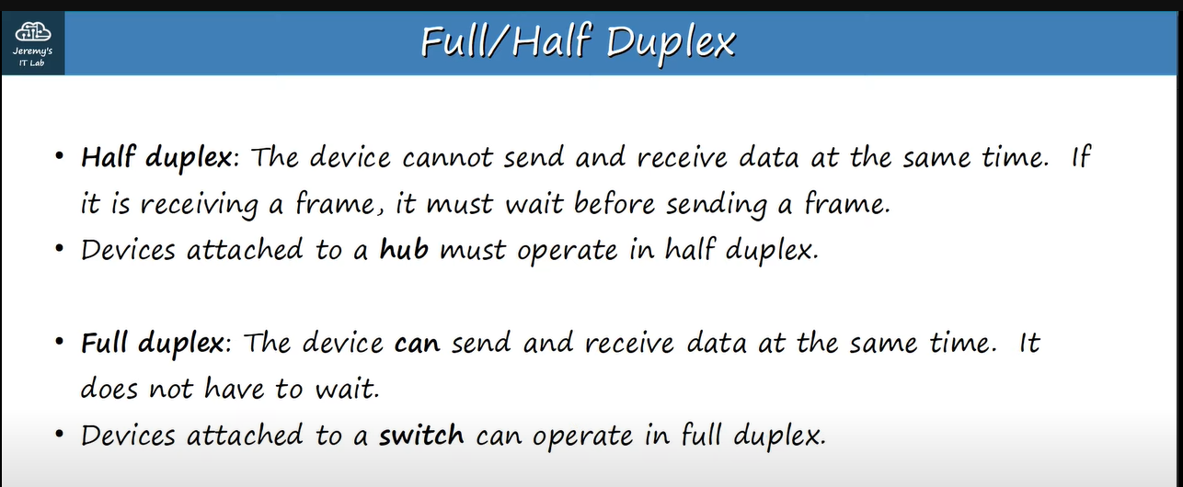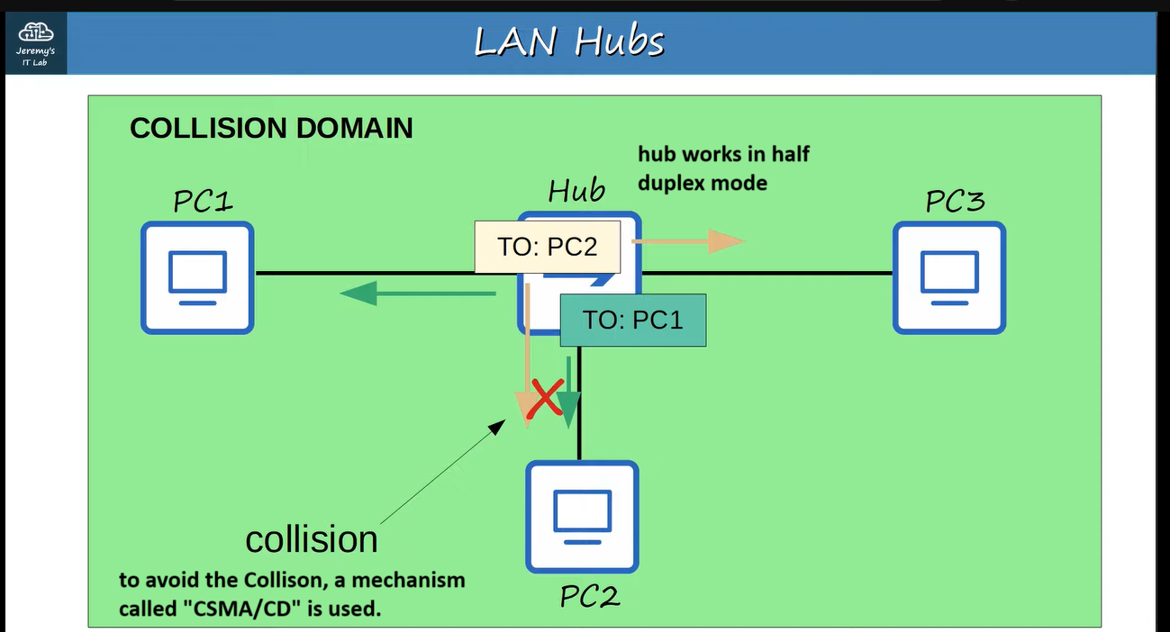

**CSMA/CD describes how devices avoid collisions in a half-duplex situation and how they react if collisions do occur.**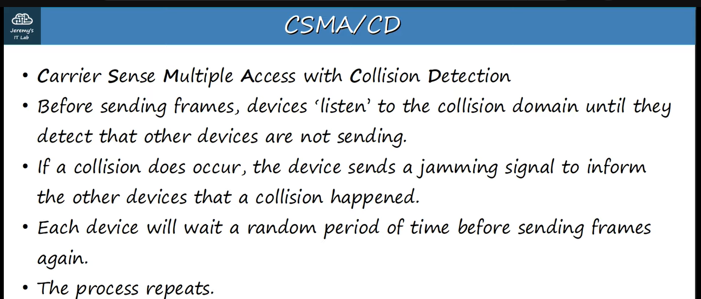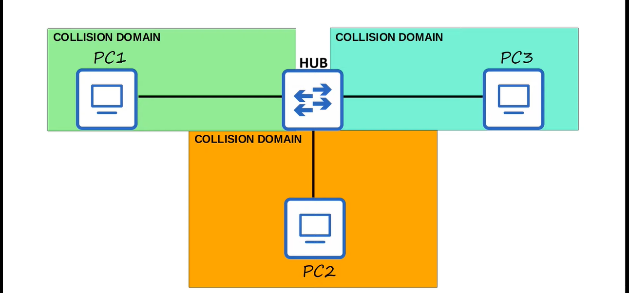

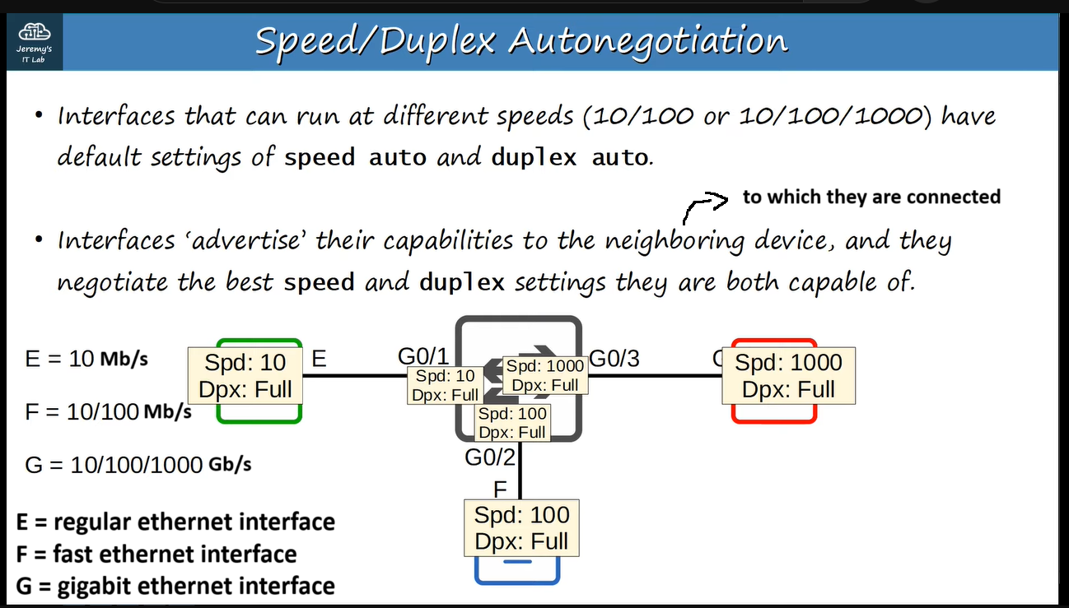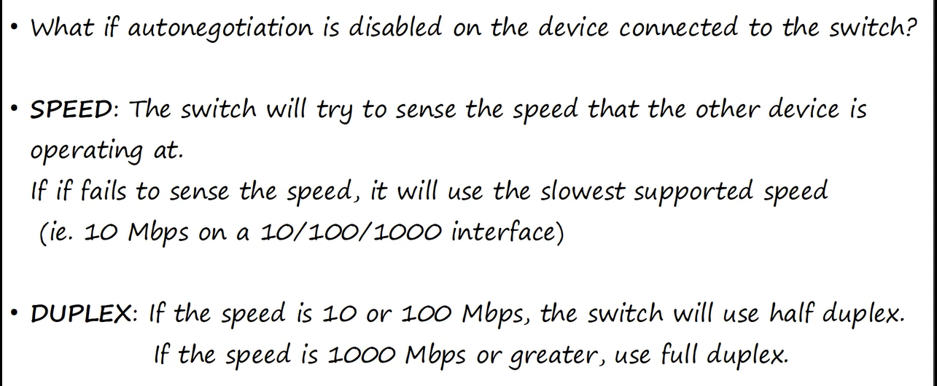**e.g. ↓**